Regulations:
A14

H.T No

Sreenidhi Institute of Science and Technology
(An Autonomous Institution)
Code No: 4FC05 Date: 20-May-2019 (AN)

B.Tech IV-Year I-Semester External Examination, May-2019 (Supplementary)
Data Warehousing and Data Mining (CSE, IT & ECM)

Time: 3 Hours Max.Marks:70

Note: a) No additional answer sheets will be provided.
b) All sub-parts of a question must be answered at one place only, otherwise it will not be valued.
c) Missing data can be assumed suitably.

Part - A Max.Marks:20

Answer all QUESTIONS.

1. | What is Knowledge Discovery Process? | [2M]
2. | Define Inter Quartile Range (IQR). | [2M]
3. | Define data reduction. | [2M]
4. | Define Correlation Analysis. | [2M]
5. | What is an Outlier? | [2M]
6. | What are Hierarchical Clustering methods? | [2M]
7. | Expand ROLAP and MOLAP. | [2M]
8. | Explain the purpose of Apriori algorithm. | [2M]
9. | Define Cosine Similarity measure. | [2M]
10. | How binning removes the noise from data? | [2M]
Part – B Max.Marks:50
ANSWER ANY FIVE QUESTIONS. EACH QUESTION CARRIES 10 MARKS.

11. | a) | What is Data Mining? Explain the steps involved in it with a neat diagram. | [5M]
 | b) | Discuss the importance of Data Pre-Processing. Explain in detail. | [5M]
12. |  | Define Data Warehouse. What are the different schemas for conceptual modeling  of a Data Warehouse ? Explain with suitable examples. | [10M]
13. | a) | Explain in detail about summarization-based characterization | [5M]
 | b) | How data generalization can be done with Attribute Oriented Induction? | [5M]
14. | a) | Explain in detail about FP-Growth Approach for the given database where Minimum Support is 3.  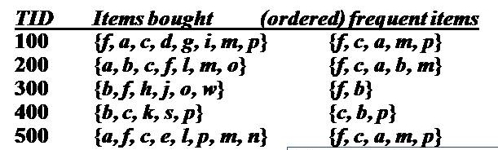 | [7M]
 | b) | What are the limitations of Apriori algorithm? | [3M]
15. | a) | What are the attribute selection measures used for decision tree construction? | [5M]
 | b) | Explain the need for Bagging and Boosting methods for classification | [5M]
16. | a) | What is Clustering? What are the major clustering approaches? | [6M]
 | b) | Explain about STING clustering approach. | [4M]
17. | a) | Explain the ETL process with data warehouse architecture. | [6M]
 | b) | What is sampling? How it will be useful in data processing? | [4M]
18. | a) | Explain Constraint-Based association mining. | [5M]
 | b) | Discuss how classification can be done using neural networks? | [5M]

-- 00 -- 00 –

